User Sequence Diagram

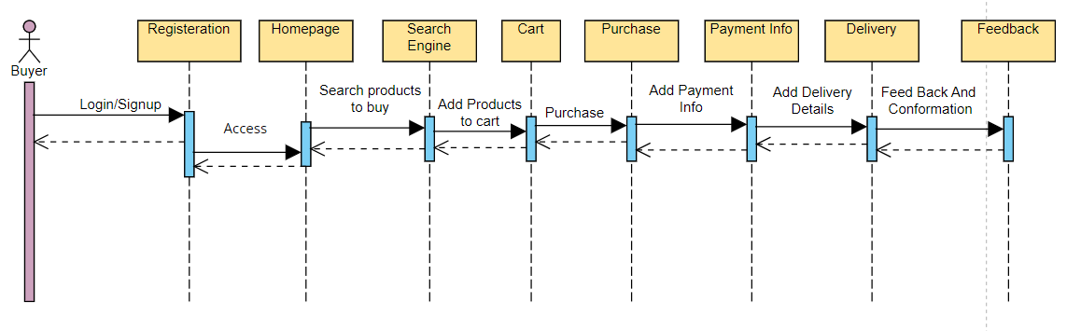

Store Owner Sequence Diagram

Admin Sequence Diagram

